Integrated Science: Physics Practice Test

Short Calculation:

- If it takes 3 hours to drive a distance of 192km on a motorway, what would be your average speed in km/h?

- What is your average speed in km/h if you travel 15km in 2 hours and 30 minutes?

- John decided to cycle to his friend’s house at a speed of 5.5km/h and the journey took 2.5 hours. How far did John cycle?

- Sally runs at a pace of 8km/h. If she ran for a period of 4.5 hours, how far has she travelled?

- If you were travelling at 32km per hour, how long would it take to travel a distance of 70km?

- The distance between two cities is 144km, it takes 3 hours to travel between these cities. What speed is the person travelling at?

- The distance-time graph shows class 8A’s journey to the zoo. They stopped for a picnic on the way to the zoo.
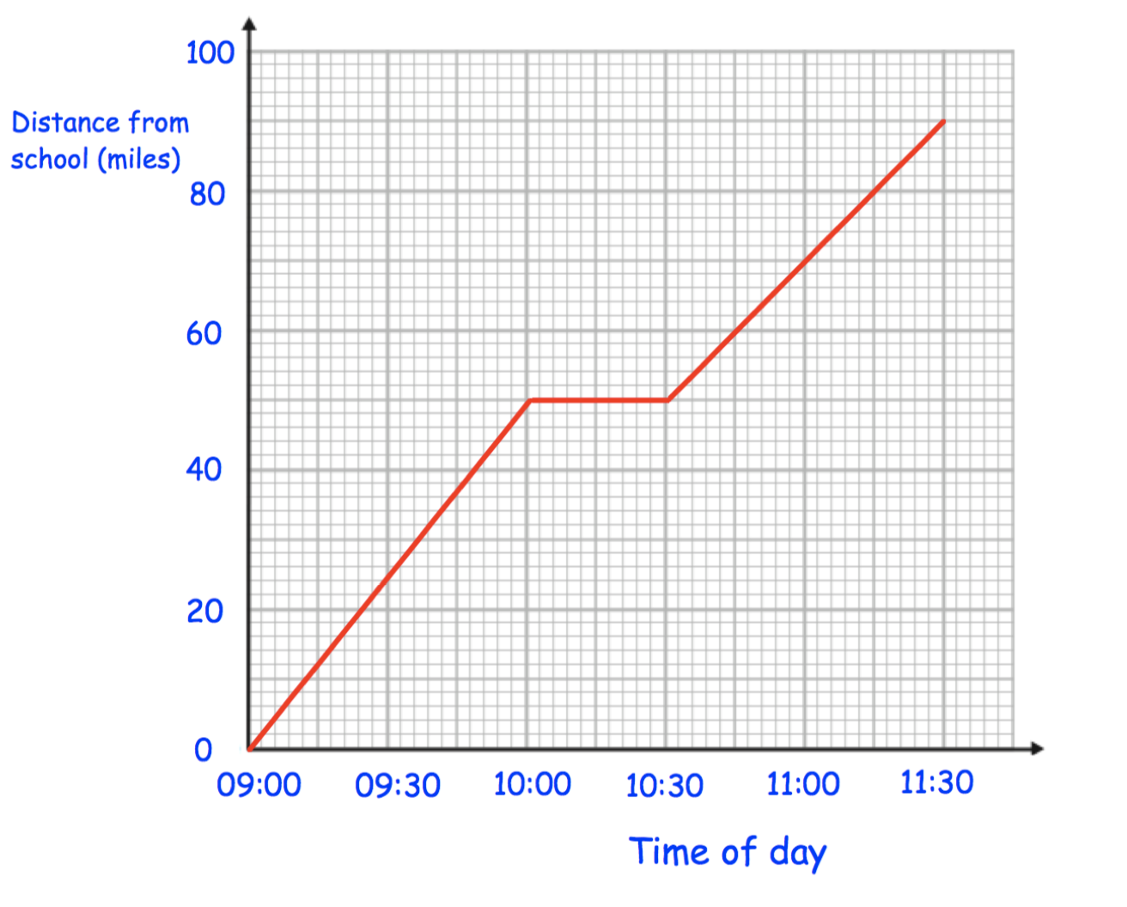

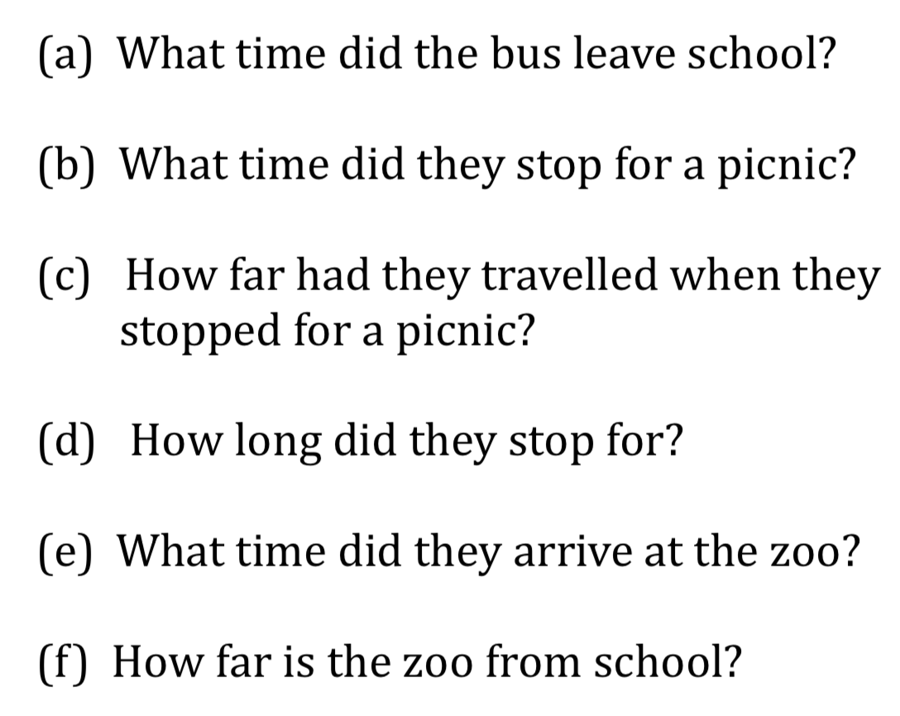

- Emma travelled to her Grandmother’s house and back.
The distance-time graph shows information about her journey.
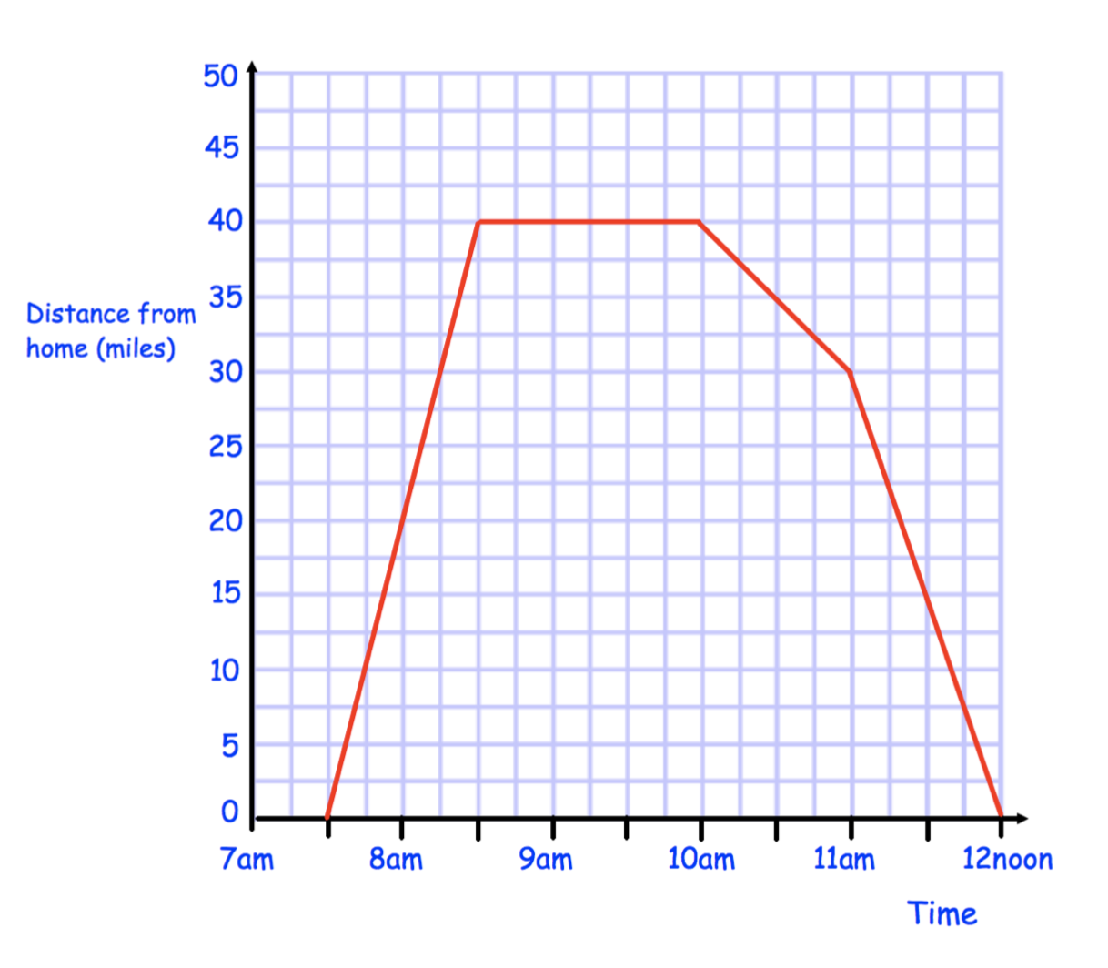
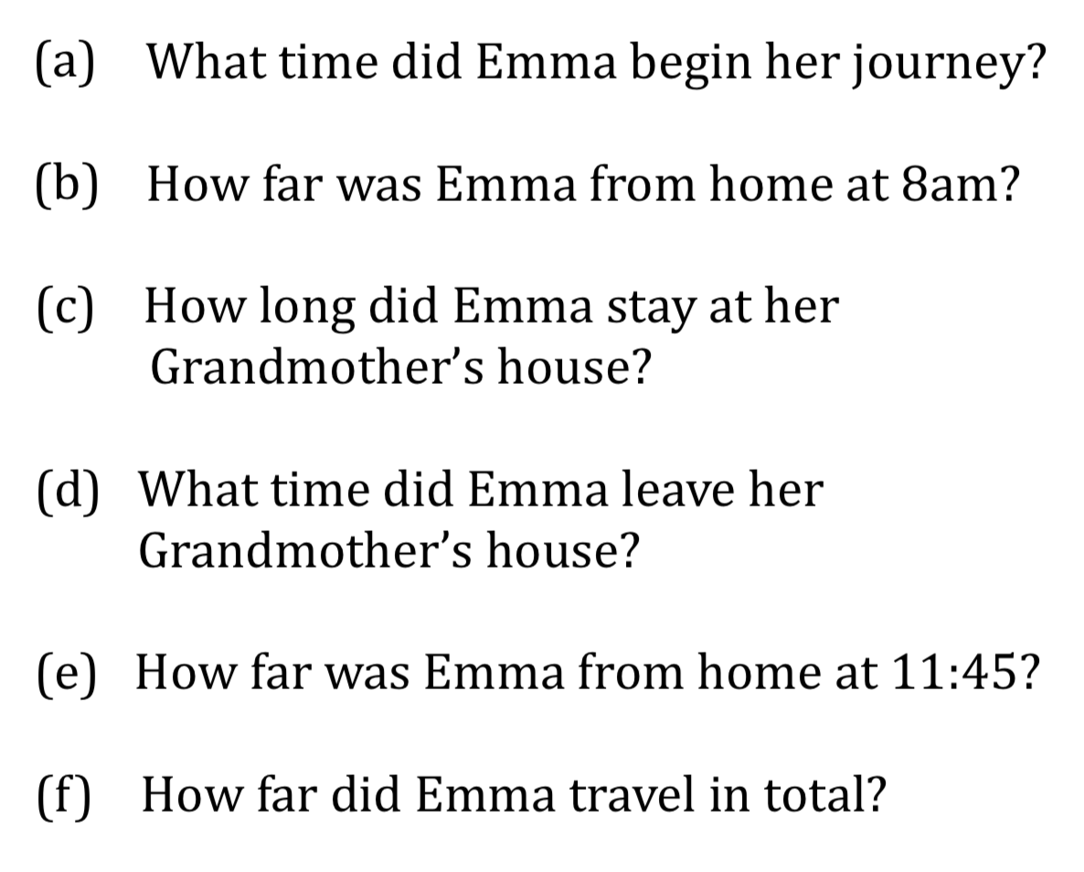

- Erin leaves home at 11am. She cycles at a speed of 16 miles per hour for 90 minutes. She stops for half an hour. Erin then cycles home and arrives at 3pm.
  - Draw a distance-time graph to show Erin’s journey.
  - What is Erin’s average speed on the return part of her cycle?



- Thomas leaves home at 14:00. He drives at an average speed of 40kph for 3 ½ hours. Thomas stops for 30 minutes. He then drives home at an average speed of 70kph.
  - Draw a distance-time graph to show Thomas’s journey



- Match the motion graph with the correct description below, then justify your choice.
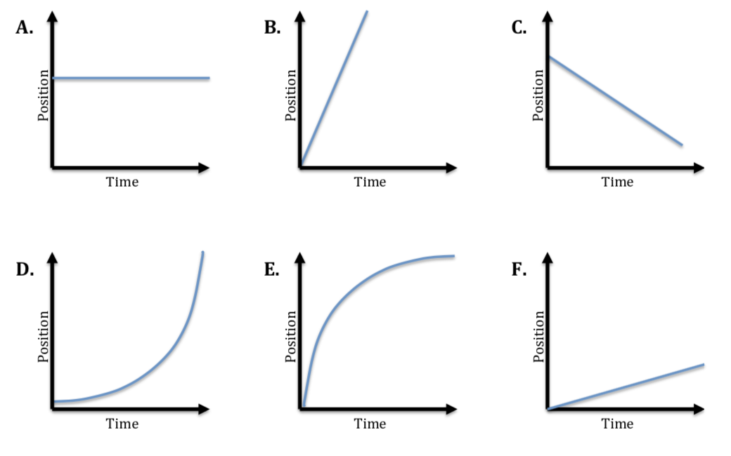

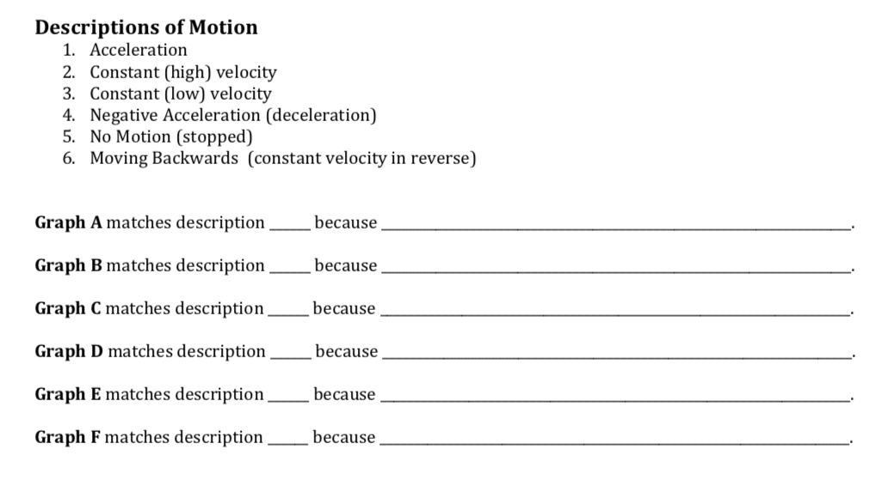

- The tickertape below was attached to the back of a toy car which then rolled down a ramp.
  - Using your pen/pencil, draw an arrow showing the direction the car travelled relative to the tickertape.

  - Calculate the acceleration of the car from the tickertape shown above. The time between each tick is 0.02 seconds.

- Energy can be broadly categorised into the following two groups, kinetic and potential.
  - Arrange the types of energy below under their correct heading.

- Nuclear
- Thermal
- Sound
- Chemical
- Elastic
- Motion
- Light
- Gravitational
- Electrical

  - Provide two examples of elastic energy, explaining how each example of elastic energy supports your decision on whether to place it under the kinetic or potential energy heading.

